In attendance: Ned Panfile, Stan Witczak & Bruce DiBisceglie (dept chair).

- Communications
  - October 2018 Mendham Borough Recreation Committee (MBRC) meeting minutes were approved.
    - Minutes and agendas have been posted to the Mendham Borough website.
  - Communications:
    - Bruce spoke with Fran Plodkowski (Mendham Business Association) about participating with the new Holiday Home Decorating contest. In addition to the MBA providing two prizes each of $100 in Mendham Money, Fran will assist Bruce and Stan with the judging Dec 14-16.
    - Jeff Cooper replied to Bruce about costs for proposed Borough Park additions.
      - A concrete practice wall for tennis (20’ wide X 10’ high) would cost approx $35,000. The MBRC recommends that placement should be just south of the pine tree line between the Orchard tennis courts and the lighted basketball courts (image below).
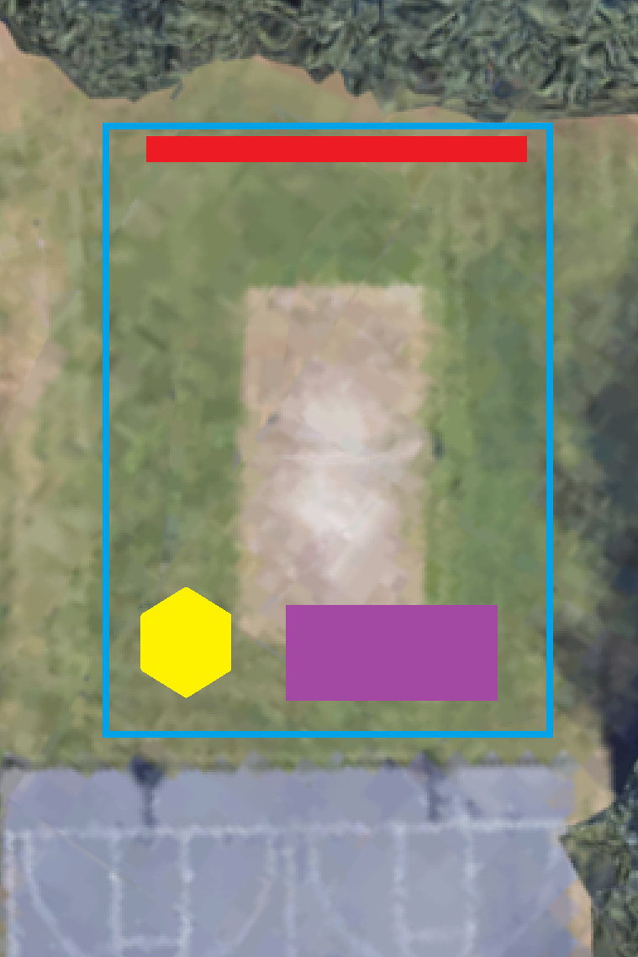
        - The MBRC felt that a wall between the two Orchard St courts could meet opposition from adjacent residents.
      - The pickleball court would be 26’ X 52’ with a prep base (4100 for quarry process), 4” base course then a 2” top coat. Costs near $20,000 (image right).
      - The Gaga Pit costs would depend on the size of the octagon selected. (image right).
15’ dia. Octagon | $3,330
18’ dia. Octagon | $3,800
20; dia. Octagon | $4,300
26’ dia. Octagon | $5,200
      - Proposed location (image right ):
            - Blue - paved area
            - Red - tennis wall
            - Gold - gaga pit
            - Purple - pickleball
    - Bruce spoke to Eric Inglis informing Eric of the Council decision to move forward with the Multi-Use Turf project. Next step is detailing public/private funding between the Council and WMSC.
    - Bruce spoke with Joyce Bushman and the MBPD about the costs of maintaining the 12 AEDs within the Borough. Batteries and pads will cost a total of $1,788, and should last 7-10 years. This will be a line item for Parks/DPW and not Recreation for the 2019 budget.
    - Bruce received an email from Izzy Pampalone, a Junior at Mendham HS. Ms. Pampalone would like to start up a youth field hockey clinic for elementary and middle school children. She would like to teach the basic skill and rules of the game. Bruce advised that Ms. Pampalone offer this as part of the Mendham Day Camp.
    - Bruce spoke with Steve Eisenstein (Mendham Twp Rec Director) to identify co-municipality programs for senior citizens.

  - Meetings (updated as of Oct 12):
    - Bruce attended the October 18 Borough Council Meeting
      - John Andrews reported on the meeting regarding the effect on traffic/parking for a multi-use court next to the first aid squad. Those in attendance (John, Bruce, Jimmy Cillo, Mike Bruin, Sgt Brian Hostler & Casey Strange) unanimously felt that parking/traffic should not be a problem.
      - The Council approved to move ahead with the multi-turf field and to resurface the tennis courts at Park & Orchard.
      - Stan reported on the new Borough-wide Holiday Lighting Contest to take place December 2018.
      - The Council approved ordinance 09-2018 which details the Grand Marshal selection process. Considerations will be based on:
        - Length of Service to the Borough
        - Diversity of contributions to the Borough
        - Positive impact to the Borough and its residents.
        - Length of time as a resident of the Borough
        - Volunteer employees of the Borough and such contributions.

- Holly Trail:
  - Bruce confirmed PA system and table set up with Jeff Cooper/DPW.
  - Bruce reported that he and his wife Kathy will be distributing hot chocolate and donuts during the Tree Lighting Ceremony and Children’s Choir on Saturday December 1st from 3-5pm.
  - Bruce will talk to the music director about coordinating the concert with the arrival of the fire truck and “guest”.
  - Ned offered to be in attendance to assist if needed.

- 2019 Field Allotment:
  - Bruce has sent out 2019 field request invitations to the sixteen organizations that have submitted field requests over the past two years.
  - Replies/submissions are already being received.
  - Bruce will send out a second reminder to those of the sixteen that did not submit. This 2nd reminder will be sent during the first week of December.

- 2019 Staffing:
  - The terms of Bud, Melissa & Amy will expire on Dec 31, 2018. Bruce will contact Bud, Melissa & Amy to inquire if they wish to extend their terms or if they choose to retire from the MBRC.
  - Stan reported that resident Hillary Clark may be interested in filling an open term.

- Home Decorating Contest:
  - The Holiday Home Decorating Contest Entry Application and Rules have been circulated throughout the Borough.
  - The application deadline is November 30th.
  - Judging will take place the weekend of Dec 14-16
  - Winners announced on Dec 17

- Prior Business:
  - There will be a new Recreation Secretary to replace the retiring Penny Andrus effective Jan 1, 2019.
    - The job has been posted on the Borough website.
    - Bruce & Joyce are conducting interviews.

- New Business:
  - Future Recreation meetings
    - Bruce proposed that future MBRC meetings be moved to the 2nd Thursday of each month as opposed to the 2nd Wednesday
      - The move would align the MBRC with the Borough Council meetings (1st & 3rd Thursdays).
      - The move would align the MBRC with the Department Staff meetings (2nd Thursday – a.m.)
      - Currently there is an issue with having MBRC 2nd Wednesdays with Borough Council 3rd Thursdays. In November for example, the MBRC meeting is on Nov 14 and the Council meetings are on Nov 1 & Nov 15 (13 days and less than 24 hours apart respectively). With the move to 2nd Thursdays, the MBRC will always be 7 days between Council meetings allowing sufficient time to react to the first meeting and report to the latter.
      - Also, with a move to the 2nd Thursdays, the MBRC could respond to any items that arise during the Department Staff meetings earlier in that same day.
    - Beginning in January 2019, MBRC meetings will be moved to the Garabrant Center. There will be no future MBRC meetings at the Phoenix House effective immediately.
  - 2019 Recreation Budget
    - Bruce submitted the 2019 MBRC budget to Sue Giordano on October 28th.
    - The budget has minimal changes from the 2018 budget.
      - Increases: Labor Day +$100 to $14900, Park Events +$300 to $4850*
      - Decreases: Senior Activities -$500to $2000 (only $750 of $2500 used in 2018)
        - Does not and should not reflect Municipal Alliance Grant.
  - Bruce has partnered with Steve Eisenstein (Mendham Twp Rec Director) to bring programs to Senior Citizens (walking club, classes, etc) and will use the Garabrant Center as a base of operations.

Next Meeting: 7:30pm, Wednesday, December 12, 2018 at the Black Horse

